**ADVANCED SOFTWARE ENGINEERING**

**MID TERM REPORT**

**Lakshmi Bhargavi Kadali**

**16158203**

**lkkwd@mail.umkc.edu**

**CONTENTS**

1. **Design**
2. **Architecture Diagram**
3. **Class Diagram**
4. **Features Implemented**

**a. Web Services**

**b. Database**

**c. Mobile User Interface**

1. **Screenshots**
2. **Github URL**
3. **URLs and References**
4. **DESIGN:**

**Architecture Diagram**

This is the architecture diagram of the application which I have developed.

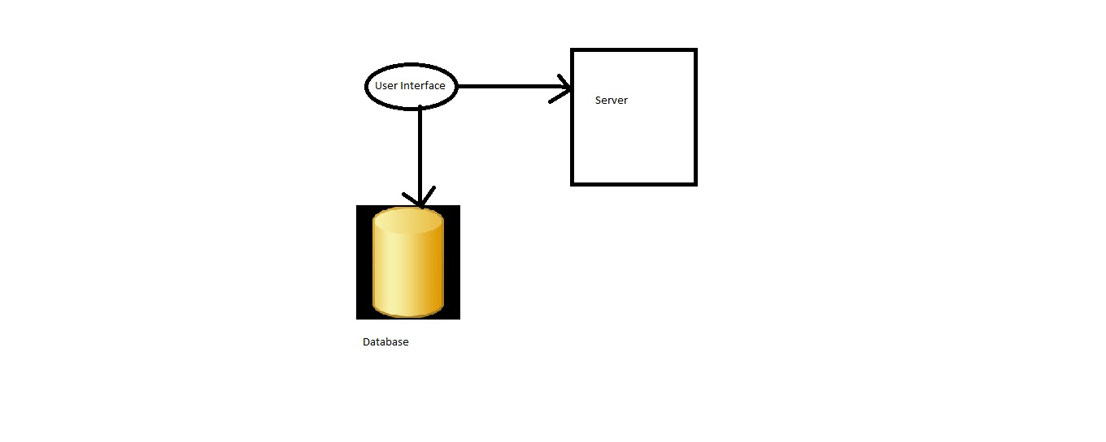

**Class Diagram**

This is the class diagram that shows various relationships between all the classes involved in the web application that I have developed**.**



1. **Features Implemented:**

**Web Services**

The different web services that I have provided to the user using this application are:

* Sign up to the application
* Login to the application
* Maintaining the user profile
* Sign out to the application
* Creating routes
* Tracing the routes
* Choosing the routes

**Database**

The database that I have used for developing this application is SQL Server Database.

**Mobile User Interface:**

This is the mobile user interface that I have given for my application

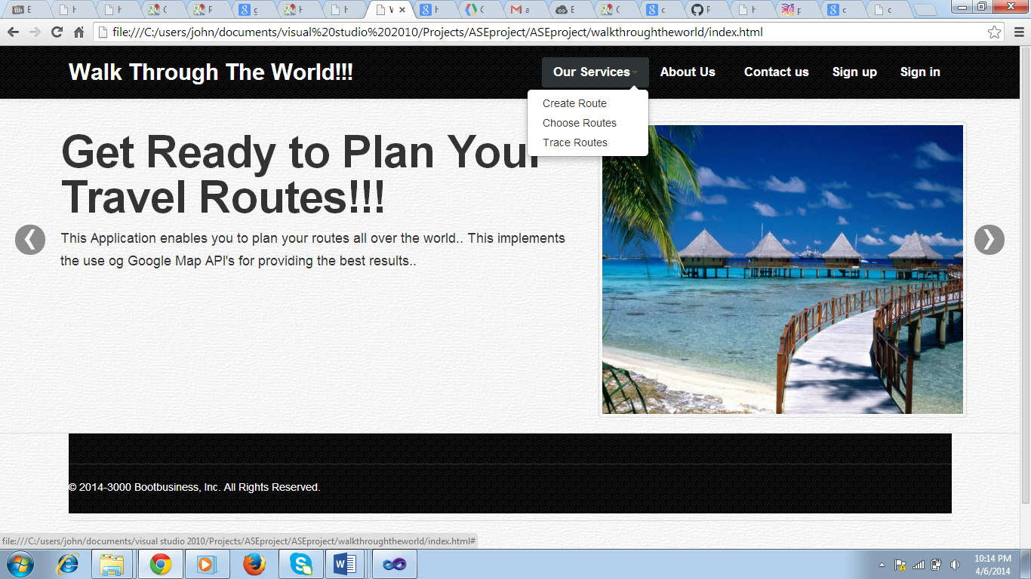

1. **SCREEN SHOTS:**

This is the home page of the application that I have developed. It provides different options to the users like sign-in, sign-up, contact us and other services that allow the users to perform different tasks. There are different images scrolling in the home page that describe about various features of this application.

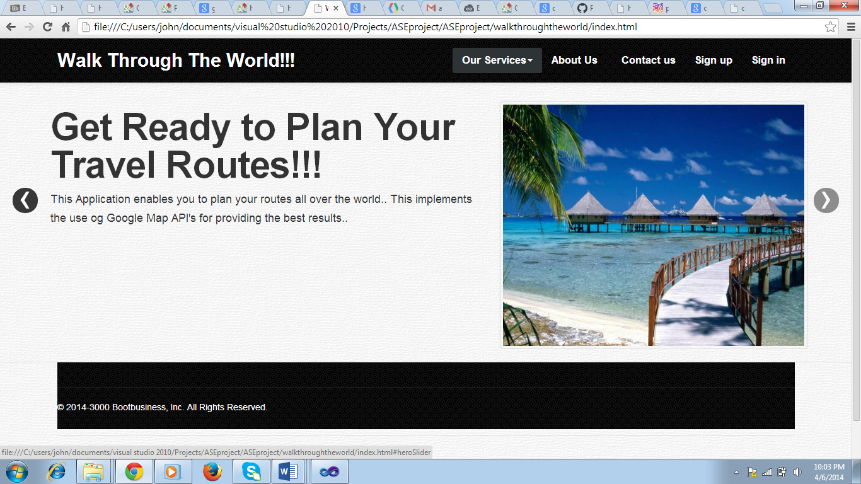

**Fig: Home Page**

This is the second page that is displayed in the application’s home page where it describes about the tracking facility provided to the users.

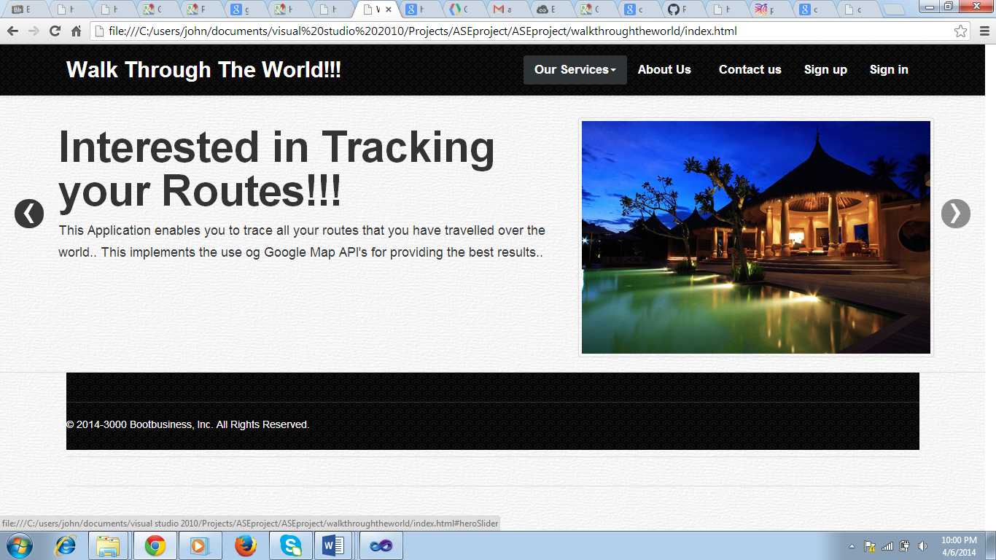

**Fig: Home Page**

This is the third page that is displayed in the application’s home page where it describes about the tracking facility provided to the users.

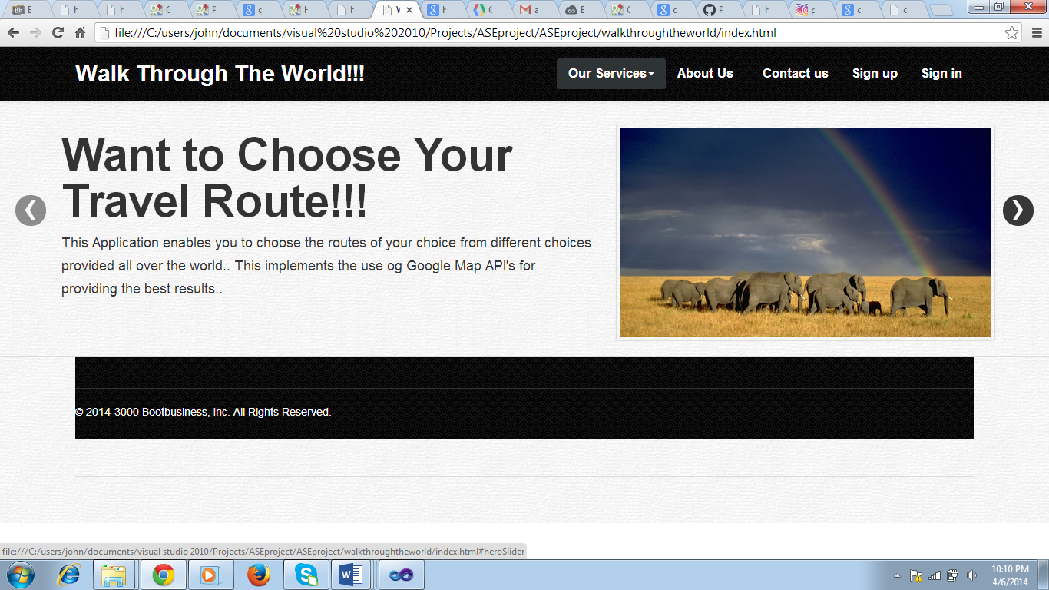

**Fig: Home Page**

This is the fourth page that is displayed in the application’s home page where it describes about the overall facilities provided to the users.

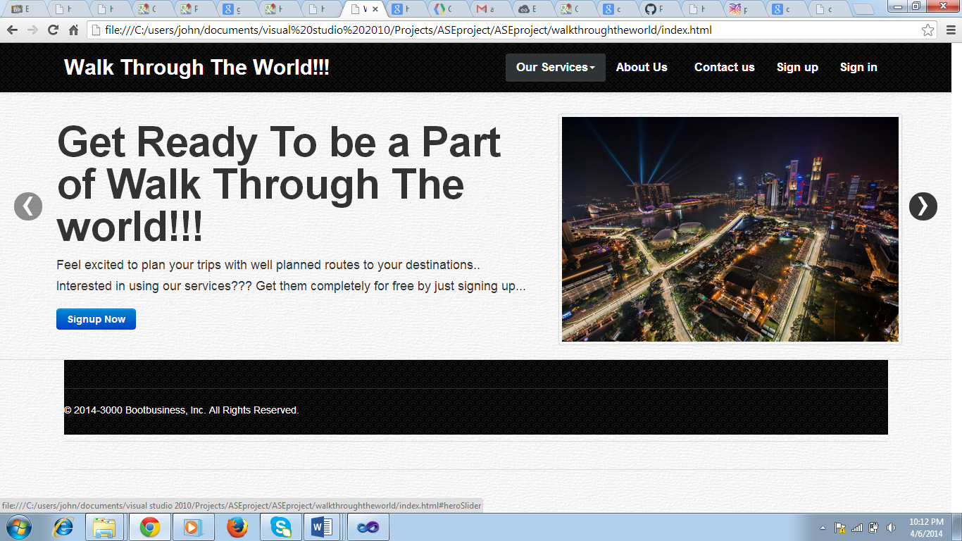

**Fig: Home Page**

And now this is the response provided by the application whent the user clicks on the Services link provided by the application.



**Fig: Home Page**

This is the page displayed to the user when About Us link is clicked by the user.

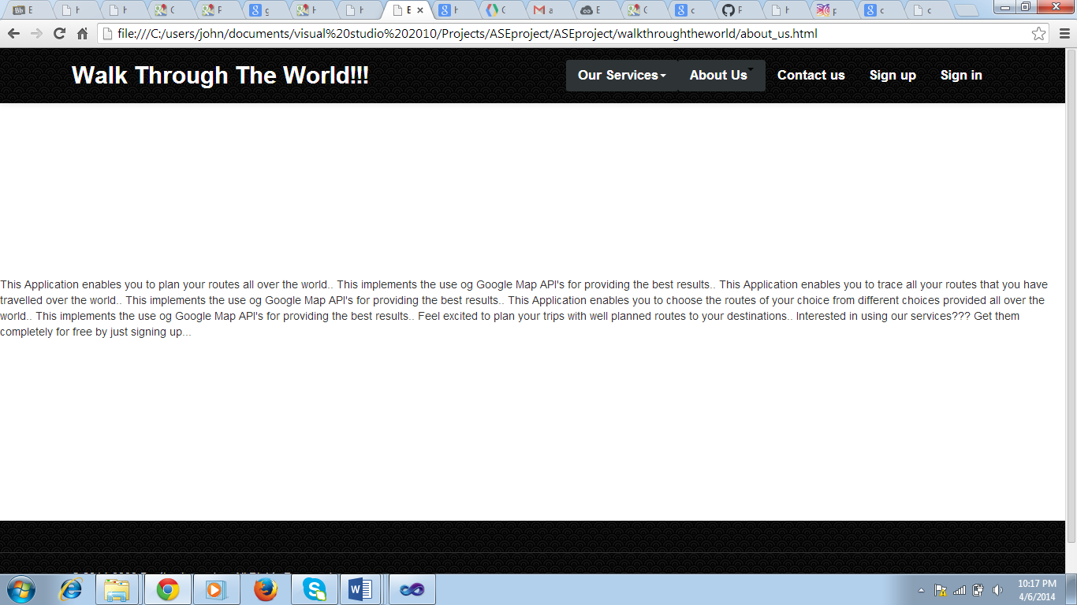

**Fig: About Us Page**

This is the response provided by the application when the user clicks on Contact us button provided in the home page.

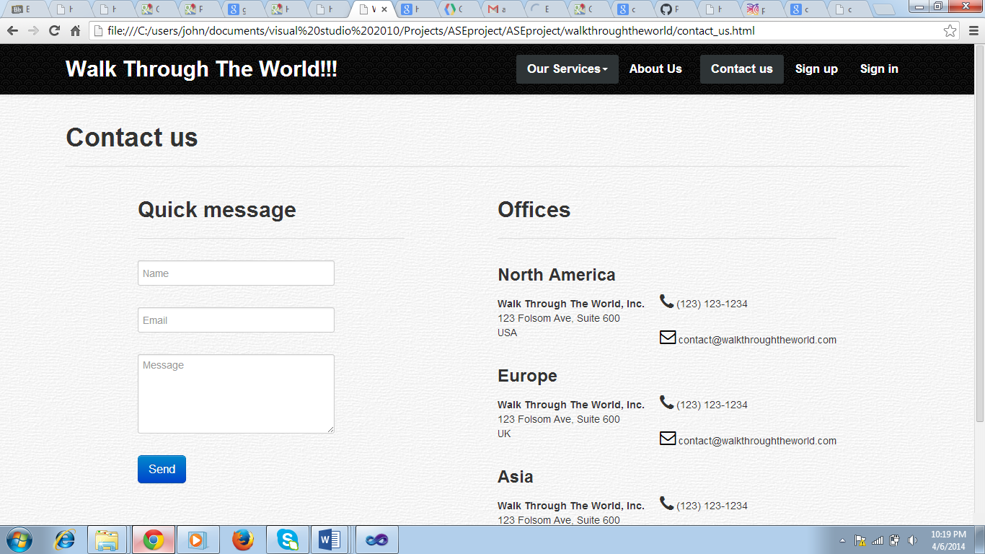

**Fig: Contact Us Page**

Now coming to the sign up option provided by the application where the user will be able to register to the application.

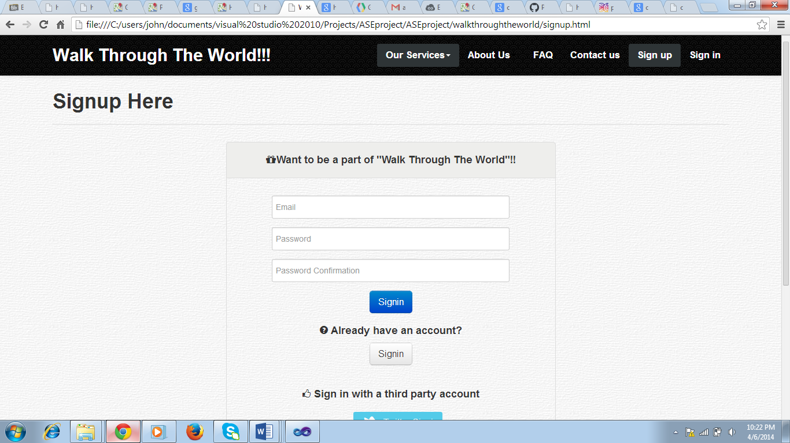

**Fig: Sign Up Page**

And this is the continuation of sign up page where the user will be able to login using other third party websites.

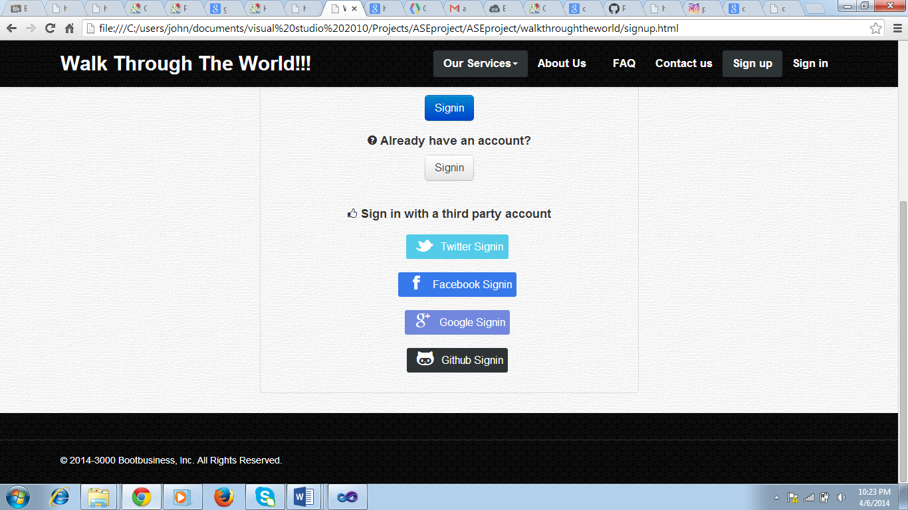

**Fig: Sign Up Page**

Now coming to the sign-in option provided by the application where the user will be able to login to the application.

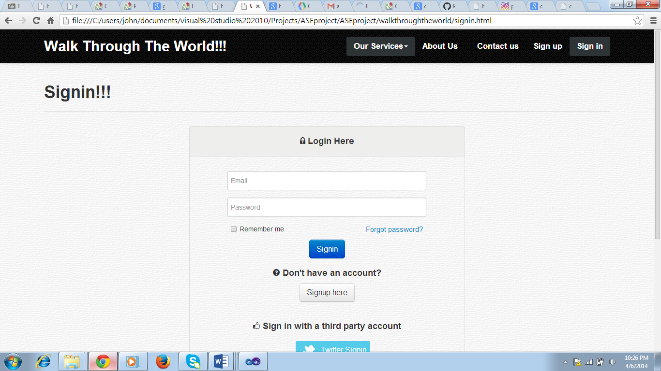

**Fig: Login Page**

And this is the continuation of sign up page where the user will be able to login using other third party websites.

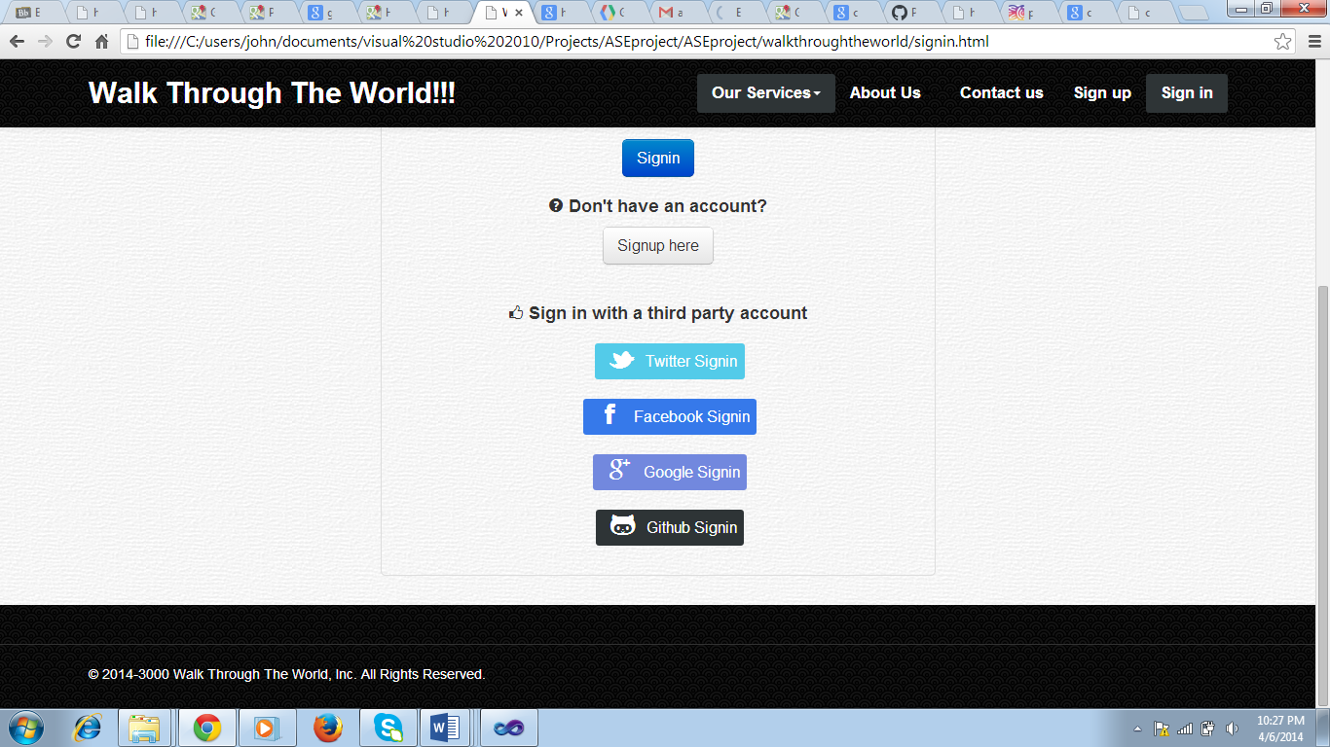

**Fig: Login Page**

This is the page that is displayed when the user gets login to the application. All the different option like

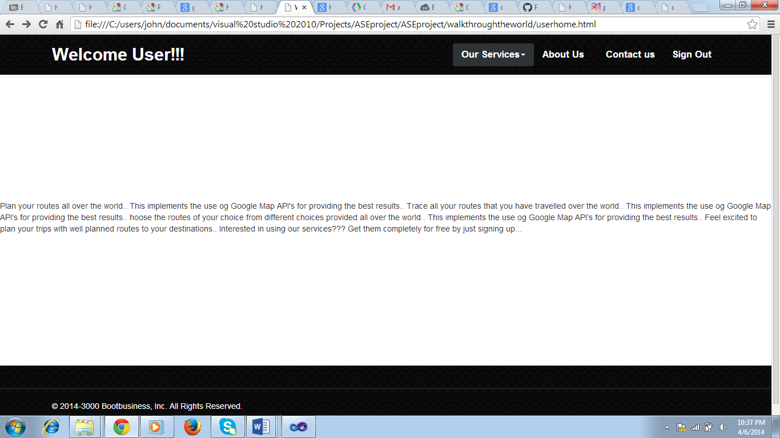

**Fig: User Page**

When the user clicks on the services button he will be displayed with three different options ie. Create route, choose route, trace route.

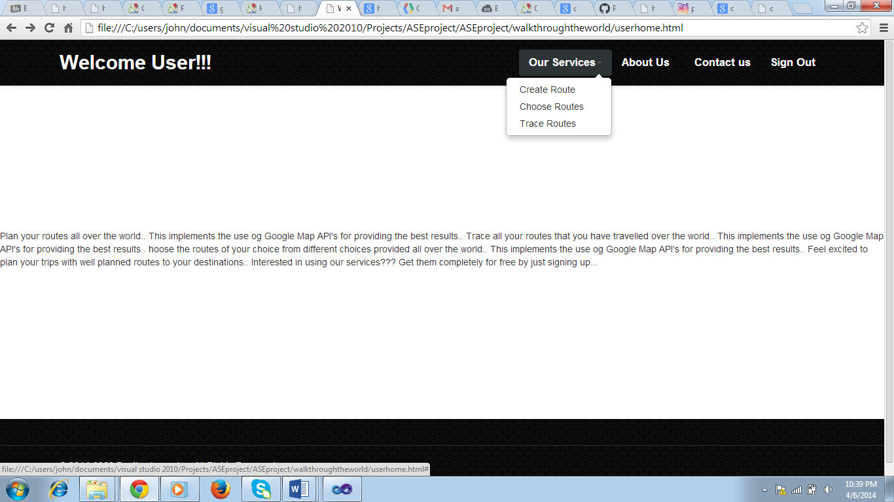

**Fig: User Page**

The user goes back to the home page of the application when he clicks the sign out button.

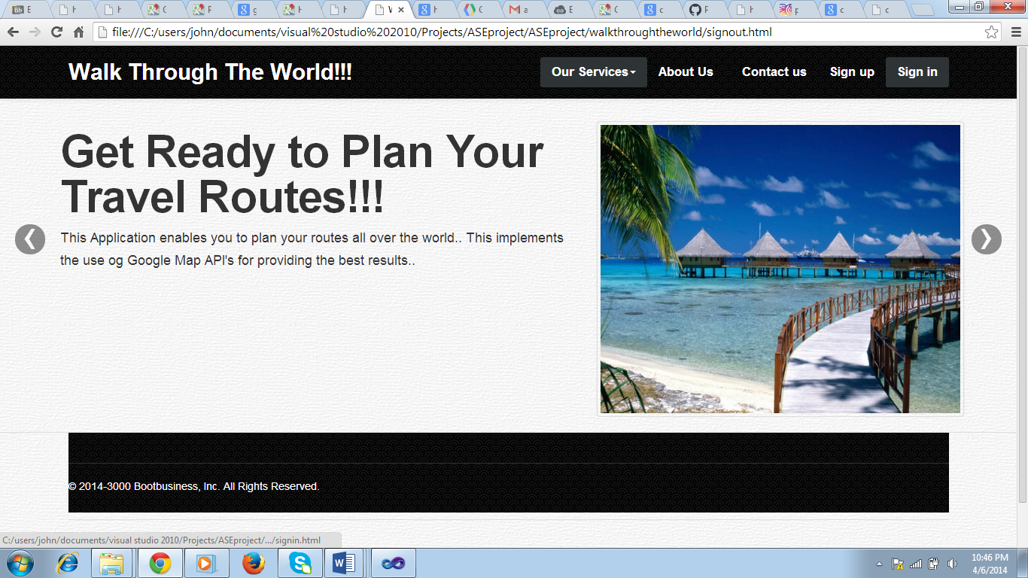

**Fig: Sign Out Page**

This is the page that will be displayed when the user clicks the create route button in the user page. Using this the user will be able to create his route by giving the source and destination in the application page.

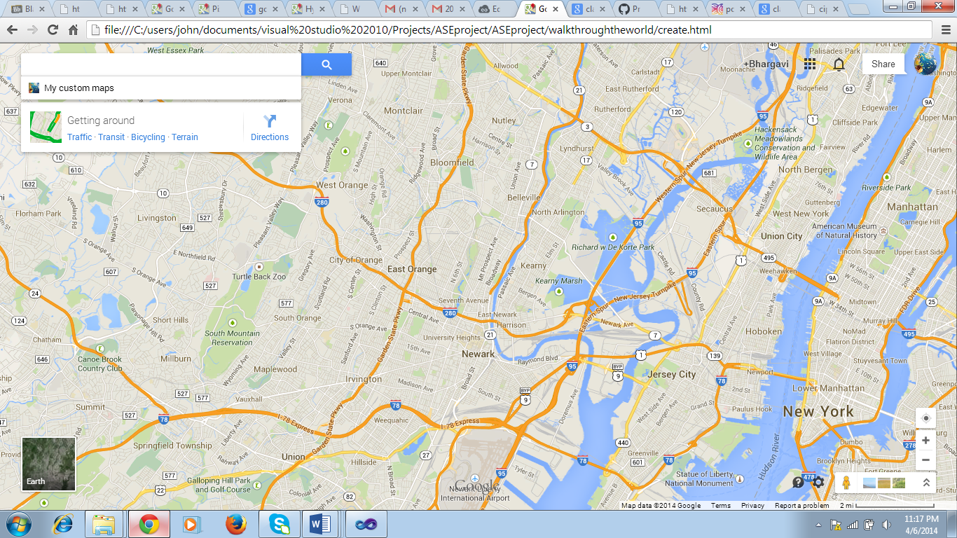

**Fig: Create Route Page**

This is the page that will help the users to trace the routes all over the world using this application.

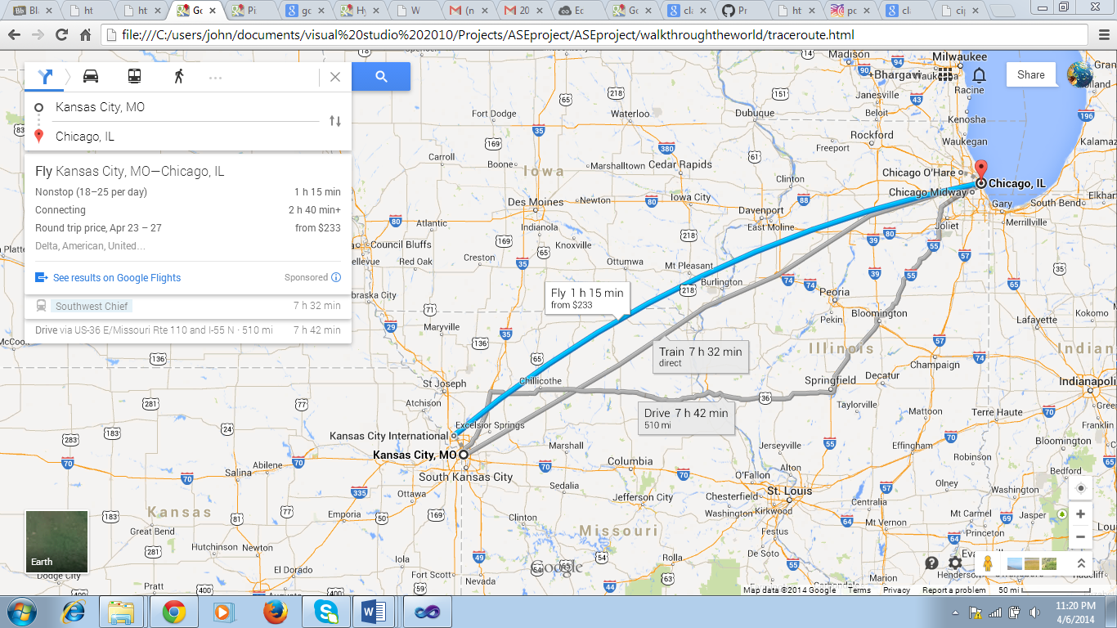

**Fig: Trace Route Page**

1. **GITHUB URL:**
2. **URLs & REFERENCES:**

* <http://portlandtransport.com/documents/OTP%20Final%20Report%20-%20Metro%202009-2011%20RTO%20Grant.pdf>
* <https://www.google.com/url?sa=t&rct=j&q=&esrc=s&source=web&cd=1&cad=rja&uact=8&ved=0CCsQFjAA&url=http%3A%2F%2Fwww.itu.dk%2Fpeople%2Fram%2FKRAK%2520Route%2520Planner2.doc&ei=Aw5CU6XDJ9KG2wW82oD4Dg&usg=AFQjCNHCwkQVhUyj9R7cnJeaCZXhcL1ENw&sig2=fVnssbhE_WiT940ZLT4HcQ>
* <https://developers.facebook.com/>
* <http://docs.aws.amazon.com/AWSECommerceService/latest/DG/Welcome.html>
* <http://www.gelib.com/simulators.html>